Project Development Phase
Model Performance Test

Date | 24 June 2026
Team ID | LTVIP2026TMIDS64613
Project Name | Visualizing Housing Market Trends: An Analysis of Sale Prices and Features using Tableau
Maximum Marks

Model Performance Testing:
Project team shall fill the following information in model performance testing template.
S.No. | Parameter | Screenshot / Values
1. | Data Rendered | Data contains 33 fields and 21609 rows  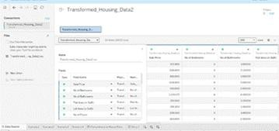
2. | Data Preprocessing | Identified 11 duplicate rows , removed unnecessary columns like zipcodes, no missing or null values.  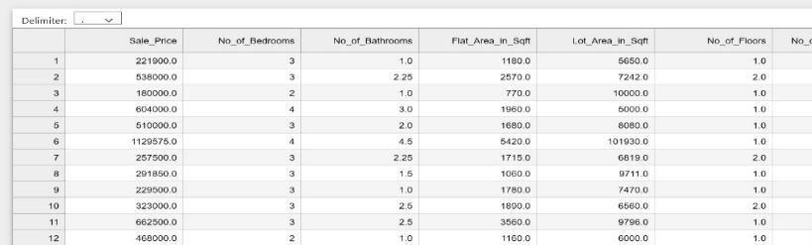

3. | Utilization of Filters | For scenario – 1  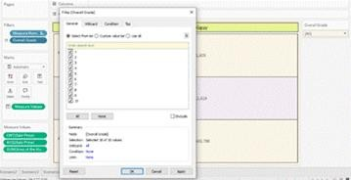  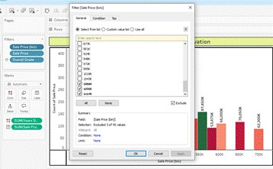  For scenario – 2  For scenario – 3  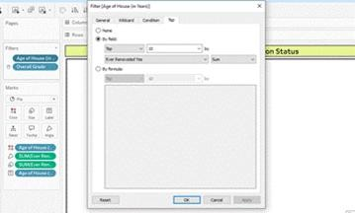

For scenario – 4
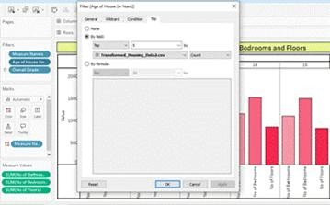
4. | Calculation fields Used | 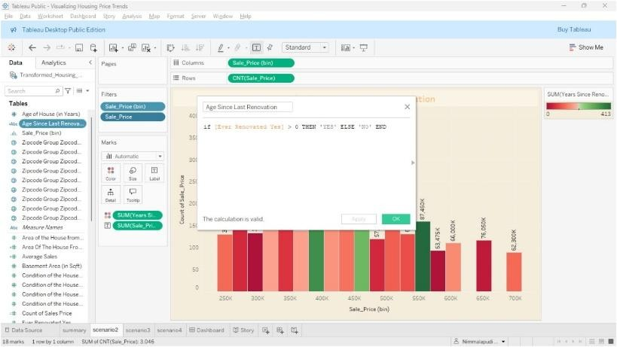
5. | Dashboard design | 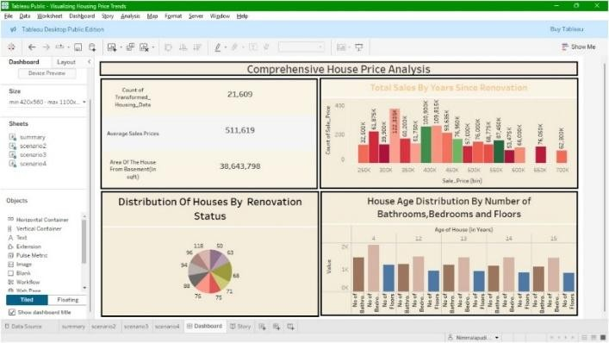  No of Visualizations / Graphs – 4  Dashboard Link : https://public.tableau.com/views/VisualizingHousingPriceTrends/Das hboard?:language=en-  US&:sid=&:redirect=auth&:display_count=n&:origin=viz_share_link
6 | Story Design | No of Visualizations / Graphs – 4  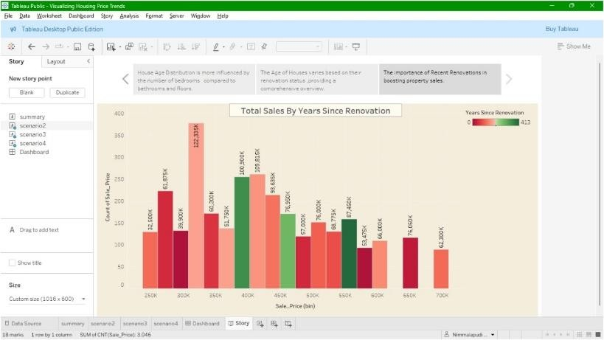  Story link :  https://public.tableau.com/views/VisualizingHousingPriceTrends/Stor y?:language=en-  US&:sid=&:redirect=auth&:display_count=n&:origin=viz_share_link

